**IFT 466 Advanced Computer Networks**

**Lab 23  
STP: Understanding the protocol**

**After you complete each step, put a ‘√’ or ‘x’ in the completed box   
or**

**Answer the open questions**

**Objectives**

* Perform basic configuration tasks on a switch
* Observe and explain the default behavior of Spanning Tree Protocol (STP, 802.1D)

1. Setup the following topology in packet tracker. I just used the standard Cisco Catalyst 2960 switch.

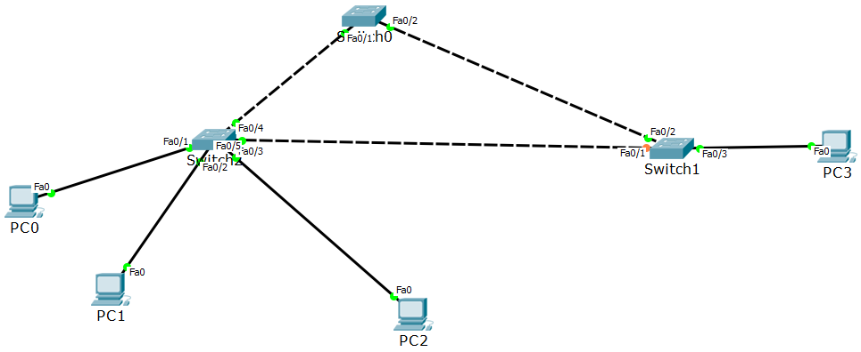

 ✓

1. Configure the following on each of the three switches.

* Configure the switch hostname.
* Disable DNS lookup.
* Configure an EXEC mode password of class.
* Configure a password of cisco for console connections.
* 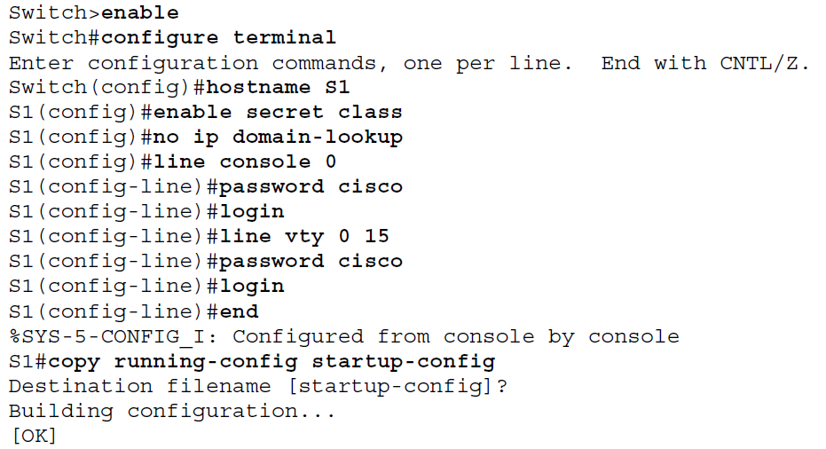Configure a password of cisco for vty connections.

Repeat the same commands on all 3 switches

 ✓

1. We will now disable all ports on the three by using the shutdown command.



Repeat the same commands on all 3 switches



✓

1. Re-enable the user ports on S1 and S2 in access mode. Refer to the topology diagram to determine which switch ports on S2 are activated for end-user device access. These three ports will be configured for access mode and enabled with the **no shutdown** command.

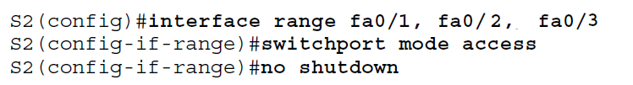

Repeat the same commands on Switch 1



✓

1. Enable trunk ports on S1, S2, and S3. Only a single VLAN is being used in this lab. However trunking has been enabled on all links between switches to allow for additional VLANs to be added in the future.

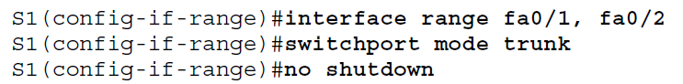

Repeat the same commands on all 3 switches



✓

1. Configure the management interface address on all three switches

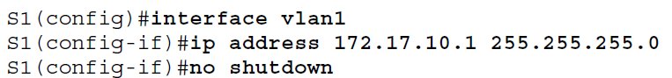

Repeat the same commands on all 3 switches

Verify that the switches are correctly configured by pinging between them.

From S1, ping the management interface on S2 and S3. From S2, ping the management interface on S3.

Were the pings successful? _____**YES**______________________________________

If not, troubleshoot the switch configurations and try again.



✓

1. Configure the Ethernet interfaces of PC1, PC2, PC3, and PC4 with the IP address, subnet mask, and gateway with the information below.

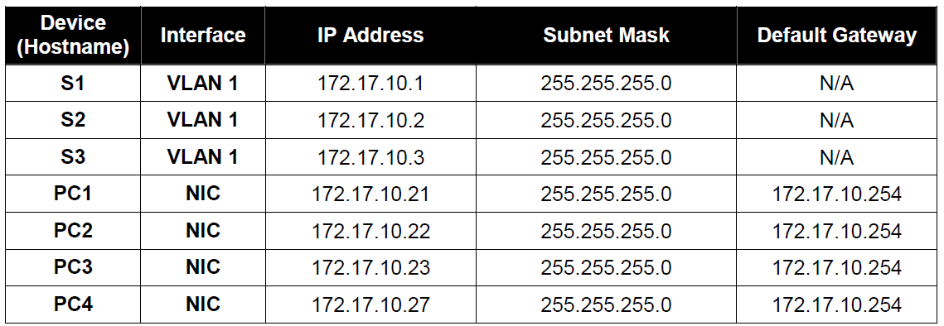



✓

1. Examine the default configuration of 802.1D STP. On each switch, display the spanning tree table with the show spanning-tree command

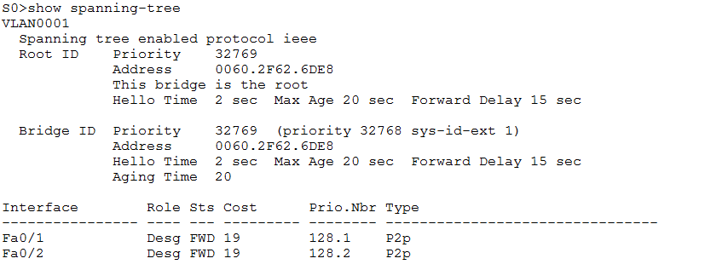

Repeat the same command on all 3 switches



✓

1. Examine the output from the show spanning-tree command

The bridge identifier (bridge ID), stored in the spanning tree BPDU consists of the bridge priority, the system ID extension, and the MAC address. The combination or addition of the bridge priority and the system ID extension are known as the ***bridge ID priority****.* The system ID extension is always the number of the VLAN. For example, the system ID extension for VLAN 100 is 100. Using the default bridge priority value of 32768, the ***bridge ID priority*** for VLAN 100 would be 32868 (32768 + 100).

The **show spanning-tree** command displays the value of ***bridge ID priority***. Note: The “priority” value within the parentheses represents the bridge priority value, which is followed by the value of the system ID extension.

Answer the following questions based on the output from the three show spanning-tree commands.

1. What is the bridge ID priority for switches S1, S2, and S3 on VLAN 1?

a. S1 **32769**_______

b. S2 **32769**_______

c. S3 **32769**_______

2. Which switch is the root for the VLAN 1 spanning tree? ____**S3**____________

3. On S3, which spanning tree port is in the blocking state? __**In my topology, Blocking port in present in swtich1 at port fa0/2_______** (refer below screenshot)

4. How does STP elect the root switch? **_______ the switch with the lower BID wins____**

5. Since the bridge priorities are all the same, what else does the switch use to determine the root?

**By the lowest MAC address.** _____________________________________

